INSTALL ANSIBLE

**How to Install Ansible**

**Step 1: Update Your Control Node**

Execute the below command to update the existing packages in the OS.

yum update for rhel or apt update for ubuntu

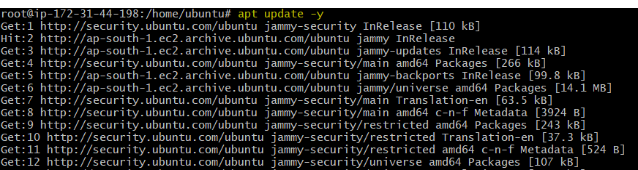

**Step 2: Install Software properties**

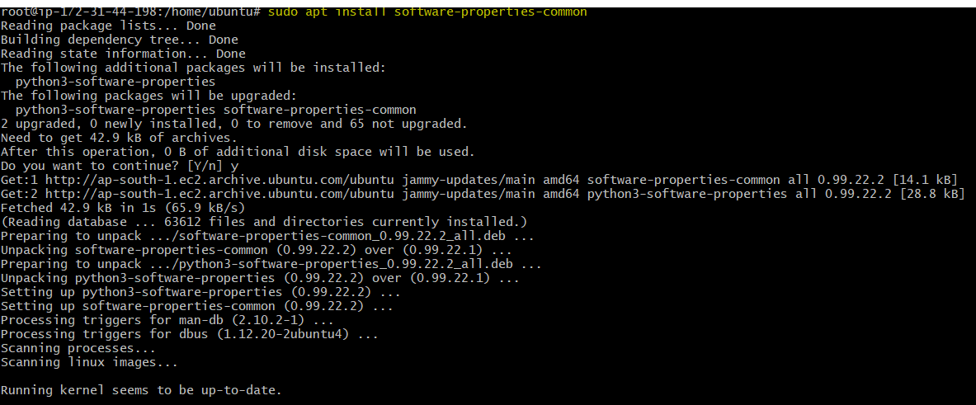

**Step 3: Install Ansible**

Execute the below commands in sequence to update the ‘Yum’ repository and install Ansible.

apt install ansible –y

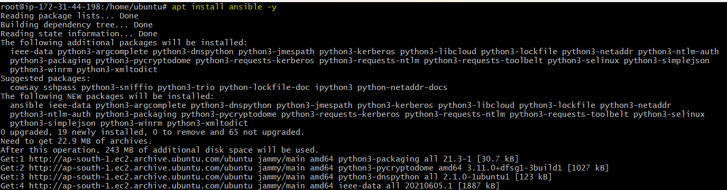

**Step 4: Create a User for Ansible**

Execute the below commands in sequence to create a user for operating Ansible jobs.

useradd ansibleadmin

passwd ansibleadmin

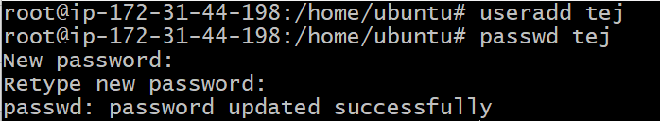

**Step 5: Configure Our ‘ansibleadmin’ User for SSH Access**

Create the SSH public and private key pair.

ssh-keygen

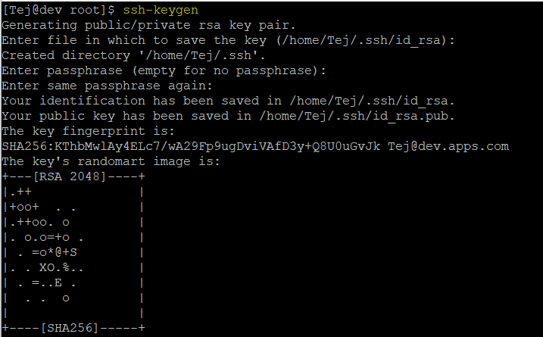

Copy the public key and paste it to our Managed node with the below command.

ssh-copy-id <nodes_name>@<IP_Address>

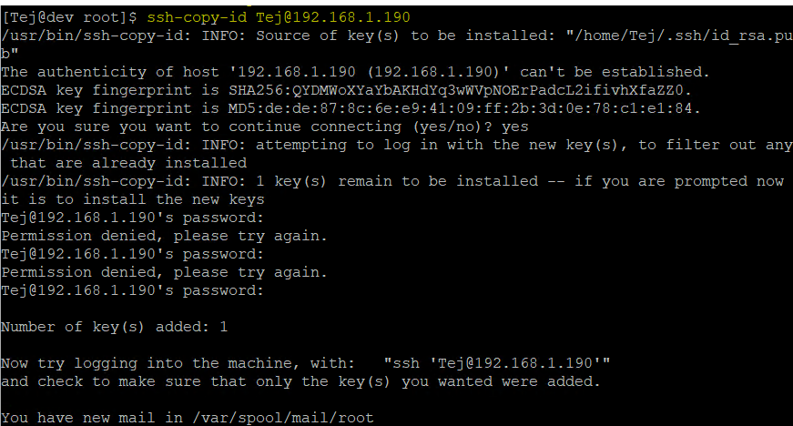

**Step 6: Create an Inventory**

Create and configure an inventory list of your managed nodes.

vi /home/etc/ansible/hosts



add the hostname of the Managed Node.

<server_ip_address> ansible_ssh_user=<user_name> ansible_ssh_pass=<user_password>

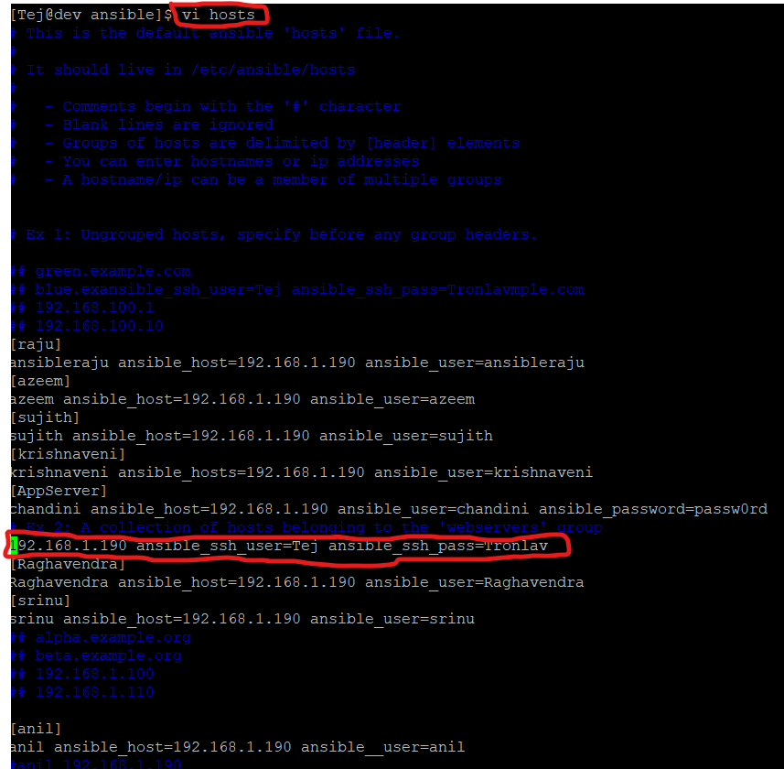

**Step 7: Create an Ansible Playbook for installing Nginx on the Managed Node.**

On the Master node, enter the following commands to configure the playbook

vim /home/simplilearn/install-nginx.yml

Enter the below code in the install-nginx.yml file.

---

- hosts: 192.168.100.30

become: yes

tasks:

- name: Installs nginx web server

Apt: name: nginx state: started update_cache: true

notify:

- start nginx

handlers:

- name: start nginx

service:

name: nginx

state: started

**Step 8: Run the Playbook**

Execute the following commands to run the playbook

ansible-playbook -i /home/ansibleadmin/inventory /home/admin/install-nginx.yml

**Install**